















26/04/2019

Peter Passmore



Julia Gabajova

M00568747

Assembling Mirto robot in Augmented Reality

Hendon

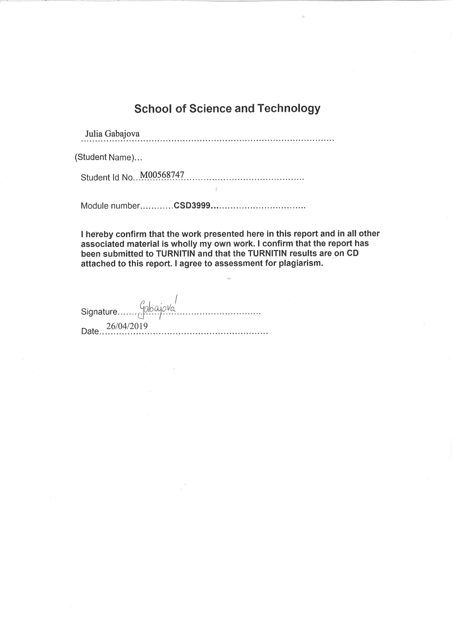

# Abstract

The aim of this project was to create a teaching tool to help students assemble MIRTO robot. The application was built for Hololens headset, but can also be used for Google cardboard headset, which is more affordable for university, to equip for this usage. Students will be following instructions in Augmented Reality instead of traditional paper handouts. I believe this will be a great opportunity for universities to bring the classes to different level of studies and build strong interest for students. The project will be evaluated by allowing students to use the application and collect feedback in regards to the using AR versus the use of paper handouts. Possible future improvements, will be provided in the conclusion section.

Table of Contents

Abstract 3

Introduction 7

Problem description 7

Aim of this project 7

Literature Review 7

Augmented Reality 7

Technologies used for Augmented Reality 8

Google Cardboard 8

HoloLens 8

Wide range of applications in different areas 9

Assembly and maintenance applications 9

Education 9

Entertainment 10

The importance of Augmented Reality in education 10

Difference between Virtual Reality and Augmented Reality 10

Unity – Development framework 11

AR Development Platforms designed by top 5 tech. companies 11

Apple ARKit 11

Google ARCore 11

Facebook AR Studio 11

Snapchat Lens Studio 12

Amazon Sumerian 12

Another best available Development Frameworks for creating mobile applications in AR 12

ARToolkit 12

Vuforia 12

Wikitude 12

Other kinds of frameworks available 13

Overview of targets provided by Vuforia 13

VuMarks 13

Image Target 14

Cylinder Target 14

Object Recognition 14

Model Target 14

Multi Target 14

Inside-out and Outside-in tracking approaches 15

Requirements Specification 16

Functional requirements 16

1. Detect part of the robot front of the camera 16

2. 3D animation 16

3. Text overlay 16

4. Removing part from the AR view 16

5. Buttons 16

a. Next 16

b. Back 16

6. Hololens use 16

a. Voice recognition - Next 16

b. Voice recognition - Back 16

Non- Functional requirements 17

1. Clarity of information 17

2. Information layout 17

3. Interface design 17

4. Button specifics 17

5. Response Time 17

6. Compatibility 17

Software requirements 17

Analysis and Design 18

Application overview 18

Use cases 19

Use case from the player perspective 19

Use case from the console perspective 19

Activity diagram 20

From the perspective of a client 20

From the perspective of a system 21

Sequence diagram 22

Start the application 22

User press NEXT 23

User press BACK 23

Implementation 24

Research methods 24

Creating an application 24

Implementing prototype into Hololens 30

Testing and Results 31

Testing the app in Unity 31

Testing the Image Targets 31

Testing the Object Targets 31

Testing the animation and the sound 31

Testing the buttons 31

Testing the app on Microsoft Hololens headset 32

Testing Voice recognition 32

Evaluation and Further Work 32

Methods 32

Questionnaire types 32

Justification for my questionnaire 32

Ensuring privacy and anonymity 32

Results 32

Data-analysis 32

Aim of the results 33

Result 1 33

Result 2 33

Result 3 and Result 4 34

Result 5 35

Result 6 35

Conclusion 36

Bibliography 37

Table of Figures

Figure 1 The concept of an AR book 7

Figure 2 Google Cardboard headset 8

Figure 3 HoloLens – Minecraft 8

Figure 4 Difference between VR and AR 10

Figure 5 VuMarks example 2 13

Figure 6 Vumarks example 1 13

Figure 7 AR Nexo Knights Lego game 13

Figure 8 Image Target - astronaut 14

Figure 9 Multi Target 14

Figure 10 Outside-in and Inside-out tracking approaches 15

Figure 11 18

Figure 12 20

Figure 13 21

Figure 14 Sequence diagram 1 22

Figure 15 Sequence diagram 2 23

Figure 16 Sequence diagram 3 23

Figure 17 Futures and rating of Image Target 24

Figure 18 Cuboid target 25

Figure 19 Object scanning target 25

Figure 20 Object scanning 26

Figure 21 Motor- object target 26

Figure 22 uploading .od file 26

Figure 23 27

Figure 24 27

Figure 25 Animating part - code 28

Figure 26 28

Figure 27 28

Figure 28 29

Figure 29 29

Figure 30 29

Figure 31 Two Attached 3D parts 30

Figure 32 Assembling instructions 30

Figure 28 object target - motor 31

Figure 34 33

Figure 35 33

Figure 36 34

Figure 37 35

Figure 38 35

# Introduction

## Problem description

All of us, have evolved to think and store memory in three dimensions. In fact, when we look at information on a flat piece of paper on a computer screen or just a simple paper handout, it will take some time for the brain to translate that back into the 3D scene, for us to use it. This is a problem for many users in engineering and product design, architecture and other areas (Radke, 2018).

There could be a number of solutions to this specific problem, but I believe the best solution is to use AR to enhance learning. AR is changing the whole working process to their inability to focus way more, than just reading the simple paper handouts by visualising how things are actually done.

## Aim of this project

The aim of this project is to help students assemble MIRTO robot. The MIRTO robot is a robot that is primarily used for teaching first year Computer Science undergraduate students at Middlesex University. Rather than put a student with paper handout instructions of different components of the robot, the students will be able follow the instructions through their own devices and Google cardboard headsets. I believe this is an effective way of introducing how technology works. The low cost of this headset is one of the main reasons why it is such a great option for universities to bring the classes to different level of studies and build strong interest for students. Assembling MIRTO robot using this technology will enable students to acquire and apply the skills required. Furthermore, this project was also developed for Hololens headsets.

# Literature Review

This literature review is going to introduce what is Augmented Reality, the differences between Virtual Reality and Augmented Reality and what technologies and platforms are available for building AR applications. It also discusses sources concerning wide range of Augmented Reality applications, but mainly focuses on assembling applications and the importance of AR in education. It provides the review of different targets that Vuforia offers and lastly, will introduce two tracking approaches in AR and the main difference between them.

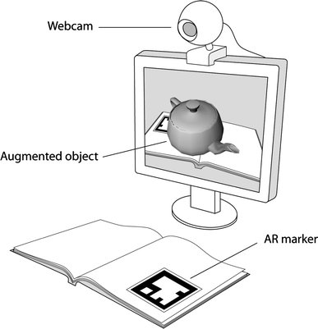

## Augmented Reality

Augmented Reality (AR), becoming one of the most innovative technologies in computer science. AR has the ability to overly the real world view with digital information or objects, using either a special equipment(headsets), a smartphone or a camera. AR becoming very popular due to the affordable hardware, which enables the applications combining these two worlds together (Mayoral, 2018).

AR Systems have the following three characteristics:

* Combines real and virtual objects in a real environment
* Interactive in real-time
* Registered and alignment in 3D

Figure The concept of an AR book

## Technologies used for Augmented Reality

AR and VR hardware landscape:

* Mobile VR (Google Cardboard, Samsung Gear VR, Google Daydream)
* Desktop VR (Oculus Rift, HTC Vive, Sony PlayStation VR)
* 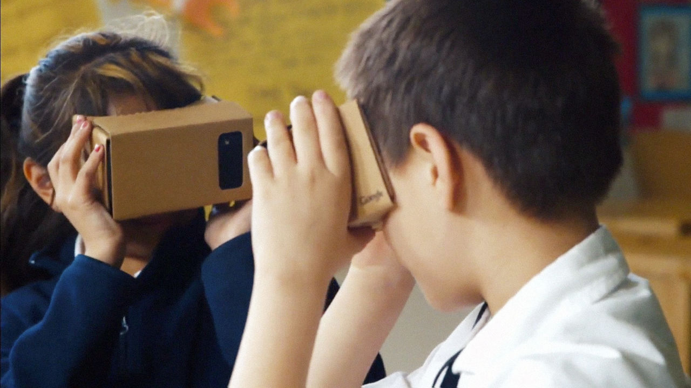AR/MR Devices (Microsoft HoloLens, Magic Leap, Google Tango, common smartphones & tablets)

Figure Google Cardboard headset

### Google Cardboard

The Google Cardboard headset was developed and published by Google. User can build their own headset or buy it at very low cost. To use this headset, users use their own smartphone together with the headset to experience the Virtual and Augmented World. To experience that, user needs to run the compatible applications on their smartphone device and then place their phone inside the cardboard headset and holds the headset close to the eyes as shown on the Figure2 above. The user can see the content through the lenses which comes together with the headset (Vr.google.com, 2019).

### HoloLens

The Hololens is a headset with transparent lenses developed by Microsoft. The headset according to Microsoft is “fully untethered, see trough holographic computer.” The user can experience immersive 3D, using this high resolution headset. For example, the user can watch movies on Netflix in the room on the wall, or build a virtual Minecraft village on their coffee table at home, as shown in the Figure3 bellow. The HoloLens headset hardware features uses a Wi-Fi, spatialized 3D sound, a fleet of accelerometers and gyroscopes, a camera with 120-degree sensing system and transparent screen combined with light-weight for individual eye. The Hololens features a holographic processing unit(HPU) along with its GPU and CPU which. The HPU is processing the holographic data and connect it with the real world (Rouse, 2015).

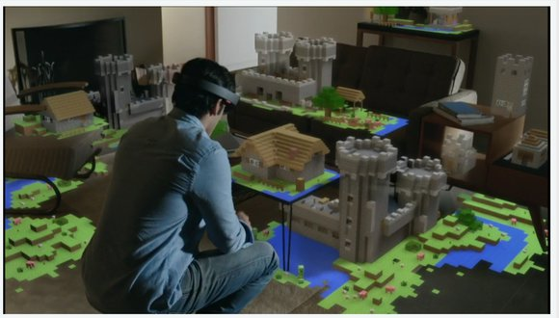

Figure HoloLens – Minecraft

## Wide range of applications in different areas

AR applications:

* Assembly and maintenance
* Education
* Entertainment

### Assembly and maintenance applications

Augmented Reality proves to be a very useful technology for various trainings in the assembling and maintenance areas. Below are listed few examples created, however there exists many more (Webel et al., 2011).

AR has a wide range of applications in different areas. For instance, regular maintenance task of assisting with plant operations. Alternatively, it can be used to train a new employee by giving them maintenance handbook, who will follow the written instructions and try to execute them would be not only slow, but there might be a risk of making a mistake which might lead to danger. A better solution would be to show the employee the exact approach by an AR tutorial, that can guide him step by step, on them to do the work (Bentley Communities, 2018).

For instance, Augmented reality vehicle manual. The Will select the area of the car that we want to learn about and point the camera to that particular part for recognition, then it overlays with animation of the various functions of the car. For example, if we want to learn how to check engine level, AR overlay animation will guide you how to do so (Goodwin, 2018).

Another significant example is assembling IKEA furniture. Who’s ever purchased this furniture know, that there is an instruction manual which needs to be followed. There is an AR application, created by Adam Pickard, for users to show where the different components belong. There is a tutorial guide on your phone with the instructions, which will appear on the top of the piece of wood with another piece of plank of wood and where the particular screws between them should go (Ong, 2018).

### Education

Using Augmented Reality in education has the ability to explain topics, which can be very difficult and dangerous to train for. For example, train medical students for brain surgery. A small mistake by the surgeon can lead to harm of the important functions of the brain. We will fill more comfortable knowing that the doctor trained to do this surgery trough Virtual world compering to the doctors just learn this from the books and watching over other doctor shoulders. Doctors can learn more effectively practicing this and transfer the virtual practice to the operating rooms. This practice will lead to minor risks of mistakes that doctors can face during the surgery. CEO of Touch Surgery, Dr. Jean Nehme, said they believe that using Augmented Reality to train doctors in classes will make surgeries for patience safer (Ranosa, 2018).

However, AR in the education sector, has a wide range of applications, and apart from teaching doctors how to do surgeries, it can have wide core range of topics such as: teaching math, science, geography etc., (Morpus, 2018).

### Entertainment

Entertainment is evolving to a different level because of AR. People often think, that experience of fun and joy today, come from areas, such as games, movies and music. Moreover, the entertainment factor is becoming more immersive, interactive and more realistic than ever before, and AR is one of the reasons why (Blum, 2018). Below, are few examples on applications created for entertainment using AR.

The Pokémon Go is one of the famous Augmented Reality mobile game. If you have not heard about this game, it overlay the real world with digital monsters. It uses GPS technology, where you try to find the Pokémon’s which could appear anywhere, such as on highway, graveyard, your garden... and the player try to catch them for some rewards. This game provides complete, compelling experience by adding these virtual creatures to the real world. It has shown programmers and developers that AR content can be very successful with mass audiences. (McCarthy, 2017).

The Snapchat, also uses an Augmented Reality features. It uses lenses, graphic masks and a design which digitally augment the camera. You can take selfies with the filters, which are the AR aspects, such as zombies, puppies, kitty and so on. It is a multimedia messaging application created for mobile devices that allow users to share photos, videos or messages with their friends similar as on the Facebook wall. The difference between Snapchat and Facebook is, that the user needs to set up 1-10seconds timing for expiration for the photo, where on the Facebook the picture will stay on the wall until we manually delete it our selfies (Kar, 2016).

## The importance of Augmented Reality in education

The application of AR in education is “an opportunity not only to use new technology to help students to learn but it will also be a shift in thinking about how we learn.” (Kevin, 2018). Using AR encourage users to develop strong practical, theoretical, but also a critical skill which enables to interact with new technologies. The student will gain more knowledge in a shorter period of time. “Introducing augmented reality to your students will enable them to **discover unknown passions and inspire their future endeavours.” (Augment News, 2018).**

## Difference between Virtual Reality and Augmented Reality

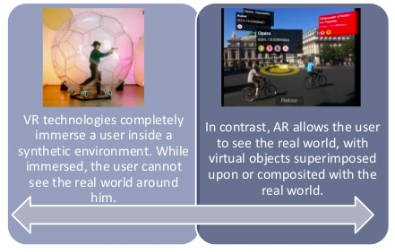It is commonly viewed, that Virtual Reality (VR) and Augmented Reality(AR) are the same. As they are both progressively used and very powerful, knowing the difference of these two technologies is very important. The differences are, that the AR overlies the real word, for example, the Pokémon Go game or using Snapchat on your mobile phone which adds elements to your camera. Whereas VR provides the complete immersion into a virtual word, where users are completely away from the real world.

AR has many advantages over the VR, one of them is that a smart phone or camera can be used to immerse with the virtual world, where for the VR requires special hardware. Another advantage of AR is that you are not completely removed from the real world. The biggest disadvantage of VR is that people often feel dizzy and nauseated after immersing in the completely virtual world (Mayoral, 2018).

Figure Difference between VR and AR

## Unity – Development framework

Unity is a development framework and game engine with lot of functionalities that help users in creating 2D and 3D dimensional games. Using this framework, allow users to import asserts to their project and add it to the scenes environment, which reduce the time, effort and cost. The asserts have various scenes, animations, lightings, audios, special effects, which could be imported into the game scene. There been several versions of Unity relisted since 2005, where previously Unity was supported Boo. However, Boo was removed in the later version -unity5 which was relisted in 2017 and also from all the above versions. Unity is using drag and drop functionality which makes it easier for developers. The scripting uses API in C# connected with the Visual studio. (Tank, 2017).

Unity has 4 license options: Personal, Plus, Pro, Enterprise

First one- Personal is for free and have lot of limitation for downloading the asserts. The other tree – Plus, Pro and Enterprise are paid licensing options (Technologies, 2019).

## AR Development Platforms designed by top 5 tech. companies

* Apple ARKit
* Google ARCore
* Facebook AR Studio
* Snapchat Lens Studio
* Amazon Sumerian

### Apple ARKit

iOS is one of the biggest platforms in the world. Apple is offers shared AR experience, where applications are no longer limited to a single device or user, but multiple users can use it at the same time. For instance, playing multiple player games. (Developer.apple.com, 2019).

Apple offeres both word tracking and facial tracking. Apple ARKit can use the sensors on the iPhone camera to approximate the light in a scene and apply the appropriate texture and shading to virtual objects. However, this ARKit is restricted to Apple users. ARKit is built in XCode using Apple framework SceneKit and Swift coding language (Medium, 2018).

### Google ARCore

The Google ARCore is identical to Apple core. The difference is that the Google ARCore applications are restricted to Android devices. This toolkit uses light estimation, spatial orientation and face detection, which are the core essential functions. The difference being that Google unlike Apple, did not build in Face ID features for the front end of the system. It is beneficial for a machine learning framework for developers. Google has their own documentation, where Apple has an “experimental plugin”. Furthermore, the Google released AR stickers feature, which are prebuilt into the mobile phone camera (Medium, 2018).

### Facebook AR Studio

Facebook AR is sufficiently different from Google and Apple. Facebook does not use the light estimation or surface detection. It mostly focuses on front facing camera. It uses Snapchat Lens studio which allows things to effect around you, not directly on your face. The platform is built into Facebook, such as fancy scripted facial animation, for example cat ears (Medium, 2018).

### Snapchat Lens Studio

Snapchat Lens Studio is almost identical to Facebook AR Studio. It uses “Face Lenses”, but also “World Lenses” that allow the user to create an imaginary world. It also can add audio, scripting and occlusion, that Facebook does not provide. Snapchat Lens Studio is open to everyone. Users can create their own lenses on “Snapcode”, and after creating the lenses, the user must send it to Snapchat for approval. However, there are some limitations to creating your own lenses (Medium, 2018).

### Amazon Sumerian

An Amazon Sumerian target is more on corporations and businesses rather than focusing on entertainment. The software is described as a solution for logistic problems that large companies might face. Amazon Web Services (AWS) users are for example, Netflix, Time, Hertz, etc. supports ARKit’s framework. However, you can run it anywhere you build it on (Vive, Rift, iOS or Android devices). An Amazon Sumerian uses WebVR and WebGL libraries where user can edit, script or import immersive 3D scenes. Amazon Sumerian uses one important feature called “Host”. Host is a Sims character integrated into the platform with two of Amazon’s tools “Poly” and “Lex”. The Host is created to guide you through different scenarios, for instance replacing real educators, managers, trainers etc. (Medium, 2018).

## Another best available Development Frameworks for creating mobile applications in AR

* ARToolkit
* Vuforia
* Wikitude

### ARToolkit

An ARToolkit is one of the software created for developing AR applications. It is an open source code with access to free library. An ARToolkit supports mapping elements via OpenGL and 2D recognition. This toolkit serves many different platforms such as, iOS, Android, Linux, SGI, Windows and SGI. Each of these operating systems needs a development environment which is free on all listed platforms. However, access to these free development libraries is very limited (Kazovskaya, 2016). An ARToolkit includes optical see-through support and stereo. This toolkit allows simple and uncomplicated collaboration for new devices (ManageEngine ADSolutions, 2019).

### Vuforia

A Vuforia is one of the leading AR platforms. It ensures reliable and robust experience. It offers freedom of creativity for developers. Vuforia support Android, iOS and UWP platforms (ManageEngine ADSolutions, 2019). SDK for AR Vuforia application development supports detection of several targets, including English text, objects and images, 2D and 3D recognition, target tracking, use of virtual buttons, scanner for scanning real objects, used for recognition, smart TerrainTM for creating a 3D geometric map, extended tracking which offers a visual experience even if the target lost the view (Kazovskaya, 2016).

### Wikitude

This library allows developers to create applications that reconstruct real world places on virtual maps. It uses a function which searches an event in real time, AR gaming, social media post and articles. It supports both Android and iOS platforms, and moreover, it supports Unity. (Iyer, 2017). Wikitude support library such as 2D and 3D recognition, scanner for scanning real objects, used for recognition, 3D model animation and rendering, location tracking and HTML augmentation (Kazovskaya, 2016).

### Other kinds of frameworks available

LayAR, KundanAR, Maxst, DeepAR, EasyAR, Xzimg, NyARToolkit, PixLive, D’Fusion, ARmedia, Metaio.

## Overview of targets provided by Vuforia

* VuMarks
* Object Recognition
* Model Target
* Multi Target
* Image Target
* Cylinder Target

### VuMarks

Same as the barcodes on products, Augmented reality uses the unique VuMarks for every particular object. VuMarks can uniquely identify any particular object.

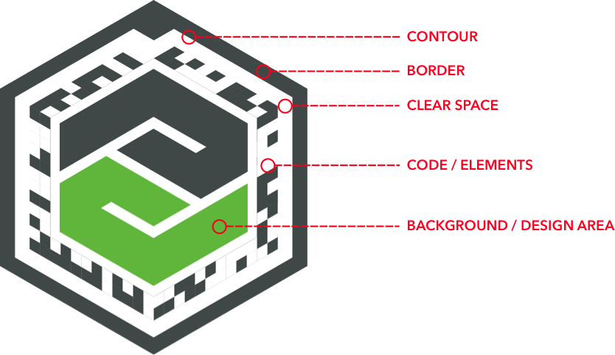

Figure VuMarks example 2

Figure Vumarks example 1

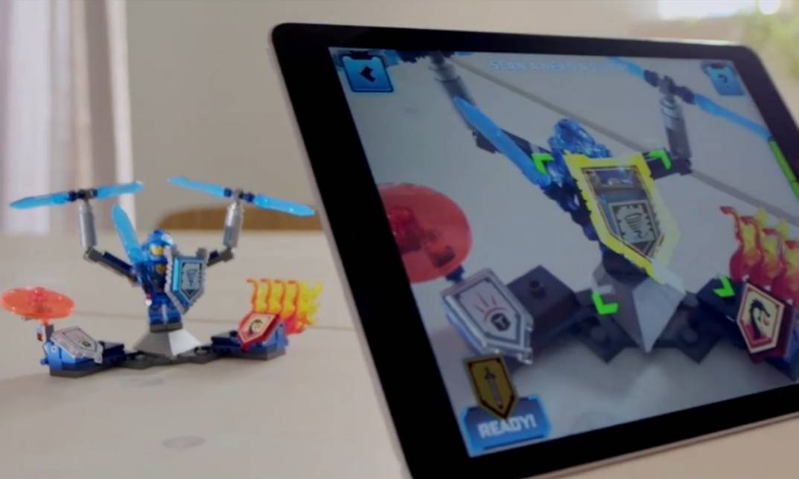Vumarks are able to track and recognize any objects such as toys, different parts of electronics devices, cars, and anything we can really think of. The consumer marks create an amazing 3D experience which are designed for instance show how to use the particular product in work fields or in a game (Library.vuforia.com, 2018).

For example, Nexo Knights Lego game, a mobile game created for children. The superheroes collect shields, which are the VuMark that unlocks Nexo power. More shields (VuMarks), the player scans, more powerful the he/she will become (iSpot.tv, 2019).

Figure AR Nexo Knights Lego game

Anyone can create their own VuMarks, however there are some design requirements which must be followed for the best recognition. Part of the Vumark is Contour. Contour is the edges around the object. It must consist of straight lines with at 4-20 sides, with the closed path. The smallest size must be at least 10% and more of the length of the largest measure of the overall VuMark. Also the angle limit is very important. The outline is maximum 150 degrees. If the angle is bigger the VuMark might not be recognized. Another design requirement is that the border width and clear space must be at least 5% of the largest length of the overall VuMark. The border cannot be transparent and must be filled with the solid colour (Library.vuforia.com, 2019).

### Image Target

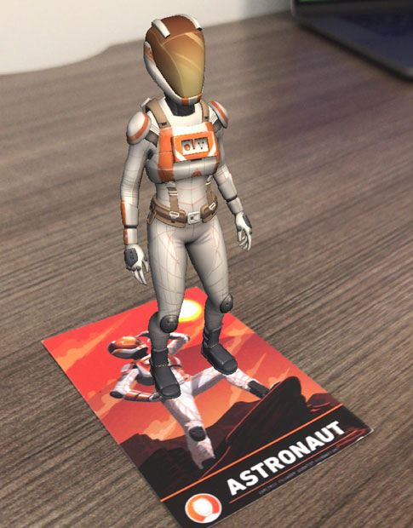

The Vuforia Engine can recognise and track various Image Targets. Unlike traditional VuMarks Image Target does not need special recognitions marks to be recognised. It naturally recognises by comparing the image to the target resource database. Once the Image is recognised, Vuforia Engine will be able to track the image moderately tracked on the camera view.

Image Targets can be created on Vuforia Developer Portal by directing to Target Manager. Click on Add Database and create a new database by creating new name. Once we name our database we are able to Add Image target .jpg or .png formats, maximum of 2mb (Library.vuforia.com, 2019).

Figure Image Target - astronaut

### Cylinder Target

Vuforia Engine has also a cylinder target which can recognise barrel-shaped image with flat base, but also with flat tops. The best example for tracking of cylinder objects are such as mugs, cans, tea cups etc. (Library.vuforia.com, 2019).

### Object Recognition

Object recognition allows you to recognise and track 3D objects. It has been designed mainly to recognise the toys, such as cars or figures, etc. Object target is created different way than the Image Target. The difference is that the Object recognition is scanned with Vuforia Object Scanner and the Image target just recognise any flat 2D image (Library.vuforia.com, 2019).

### Model Target

Model target recognise and track objects of any shape. Vuforia Engine uses a database that is specially prepared and generated by a digital 3D objects using the Model Target Generator. Computer-aided designed (CAD) models are highly recommended for Model target recognition for the purpose of capturing the geometry with a high degree of accuracy of any 3D object. For instance, the Model Target can recognise the full size vehicle

The difference between Object and Model target is that the Model target are recognised based on the geometrical data which require the CAD or 3D models and the Object Target need to be scanned using the Vuforia Object Scanner (Library.vuforia.com, 2019).

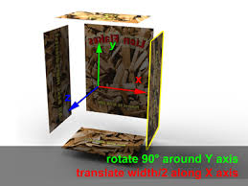

### Multi Target

A Multi Targets are created of multiple Images Targets from different geometrical adjustment. The physical position of each image is defined to the origin of the center of Multi Target. All the different angles can be recognized in the same time because the possess are predefined to the origin. This allow the entire Multi Target to be recognized and tracked when any of the child target has been identified. Multi Target is created by defining a relationship with multiple Image Targets. (Library.vuforia.com, 2019).

Figure Multi Target

## Inside-out and Outside-in tracking approaches

In Outside-in pose, the position of user is detected by an external sensor, usually done by detecting markers on the head worn device, which uses external sensor from the camera device. However, the Outside-in tracking has one major problem for a user. The issue is that it limits the range of movements of the user to the view of the external camera. Specifically spiking, the user cannot move of the view of the camera, otherwise, it will lose the tracking, also the head rotation cannot be too large not to lose the tracking as well (Pagani, Henriques and Stricker, 2016).

In Inside-out pose, the sensor is placed directly on the user or next to the user. Commonly, more cameras are used, which are placed closed to the users eyes to have a good observation angle. This tracking has multiple advantages over Outside-in. One of them is that the Inside-out pose does not have limitation of movements to specific territory of view of an external camera sensor. Another advantage is for pose estimation, when using camera, the pose can be optimized in the image plane errors for smaller reprojection. Last one, Inside-out using an Inertial Measurement Unit (IMU) the fusion has very efficient inertial and visual sound manner (Pagani, Henriques and Stricker, 2016).

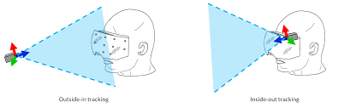

Figure Outside-in and Inside-out tracking approaches

# Requirements Specification

## Functional requirements

### Detect part of the robot front of the camera

* The user locates the image target in front of the camera view
* The Vuforia Engine will recognise the image target

### 3D animation

* After recognising and tracking the image target the system automatically overlays with first animation
* The animation will animate steps of two or more different components of robot assembling together
* The animation will be located in middle of the screen on top of the image target
* The animation automatically stops when loses the target from the AR camera

### Text overlay

* Overlay instruction text will show straight away as the player starts the application
* It will be located at the right top side of the screen
* The title of the text will tell the user which part they going to assemble
* The text will display written manual including the names of the components
* Some instructions providing tips if necessarily

### Removing part from the AR view

* The user removes the image target from the camera view
* The Vuforia Engine will lose the detection
* Animations stops

### Buttons

### Next

* After user completes first step assembling parts together, user needs to press the NEXT button
* The button will display new instructions
* The button will be located at the right side of the screen

### Back

* User can always come back to previous scenes of tutorial
* The button will display previous instructions
* The button will be located at the bottom left side of the screen

### Hololens use

### Voice recognition - Next

* After user completes first step assembling parts together, user says Next
* After recognising the word Next, the system will display new instructions

### Voice recognition - Back

* User can always come back to previous scenes of tutorial by saying Back
* After recognising the word Back, the system will display previous instructions

## Non- Functional requirements

### Clarity of information

* When displaying the manual written information, the user should easily and unambiguous understand what are the steps required

### Information layout

* The written text must have proper layout so the user does not need to spend long time on finding the steps he needs

### Interface design

* When displaying the animation, it should be clear for the user, what parts are used and how to assemble them together

### 

### Button specifics

* The button should be significantly big enough so the user will be able to easily navigate to the next or previous instructions

### Response Time

* The system should take less then 1-3 seconds when tracking the Image target
* If response time takes longer it should be concerned if it is the right image target or if the image target is fully tracked on camera

### Compatibility

* The software must be able to under all OS environments

## Software requirements

* The application is to be implemented using C# using Visual Studio 2018
* Visual Studio 2018, will be operating in Unity, Version 2018.2.19f1
* Vuforia Engine, will be operating in Unity, Version 2018.2.19f1
* The application is initialized to work on Hololens headsets

# Analysis and Design

My first stage was to define the requirements for the project by talking with Michael Margolis who designed the MIRTO robot. Then I have built up two different applications to study basic forms of ideas to recognise objects using AR through the Google cardboard headset. I was not focusing on the quality of the model, but mostly to get the “feel” of the adoption and characteristic of the design.

## Application overview

The software will be designed as shown on the Figure11 below. Once the image target will be detected, the AR will animate 6 main parts of the robot: board, top plate, skeleton, bottom plate, wheels and roller. For instance, if the user looks at the frame side plate the robot will show the animation up and down of the main skeleton where the part belongs. In the top corner of the screen will be overlay text with the manual instruction, for user to recognise the right components. At the bottom of the screen are two buttons left – BACK and right- NEXT. The button NEXT will navigate user to the new instructions and the button BACK will navigate user to the previous one.

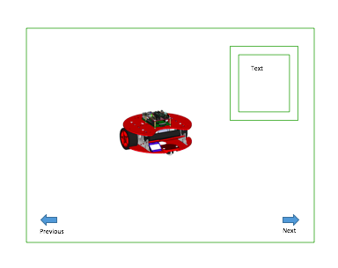

Figure

## Use cases

### Use case from the player perspective

|  |  |
| --- | --- |
| Name, identifier, version: Start the application | |
| Initiator: User | |
| Goal: Assembling | |
| Assumption: User starts following the instructions | |
| Main success scenario: | |
| 1 | The user read the instructions |
| 2 | The user pick up the hardware (MIRTO) |
| 3 | The console displays animation |
| 4 | The console displays 2 or more parts on top of the target |
| 5 | The user removes the hardware from the AR camera |
| 6* | Click NEXT or Click BACK |
| Extension: | |
| 6a | If user clicked NEXT console displays new instructions |
| 6b | If user clicked BACK console displays previous instructions |

### Use case from the console perspective

|  |  |
| --- | --- |
| Name, identifier, version: Start the application | |
| Initiator: System | |
| Goal: Console displays correct instructions | |
| Assumption: Console follows users moves | |
| Main success scenario: | |
| 1 | The console displays the instructions |
| 2 | The system track the image target |
| 3 | The console displays animation |
| 4 | The console displays 2 or more parts on top of the target |
| 5 | The console lose the tracking image target |
| 6 | The console stops the animation |
| 7 | The console stops displaying hardware |

## Activity diagram

### From the perspective of a client

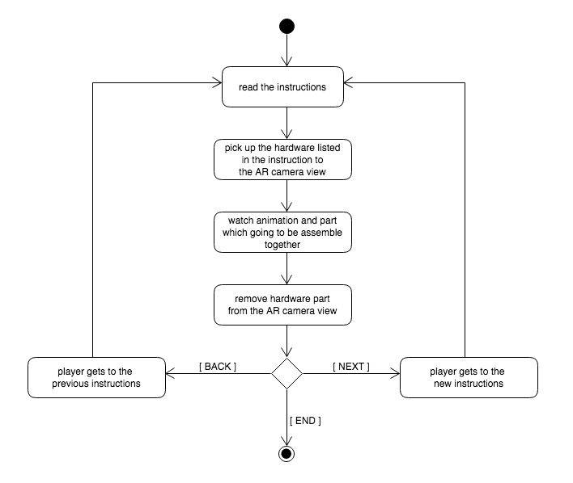

Figure

### From the perspective of a system

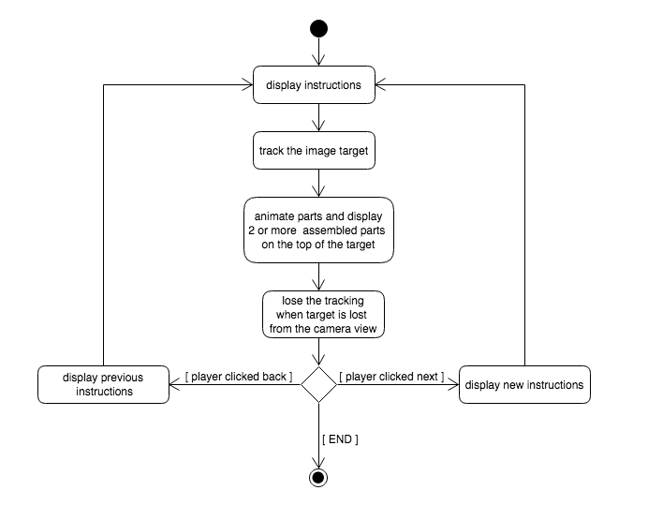

Figure

## Sequence diagram

### Start the application

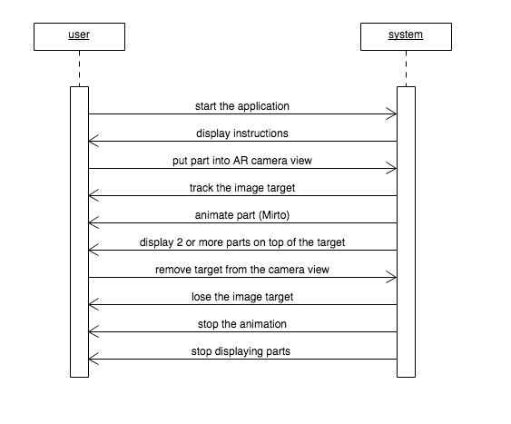

Figure Sequence diagram 1

### User press NEXT

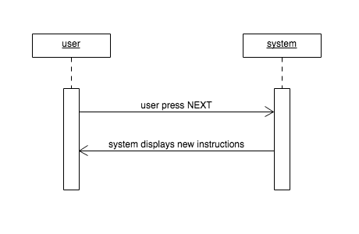

Figure Sequence diagram 2

### User press BACK

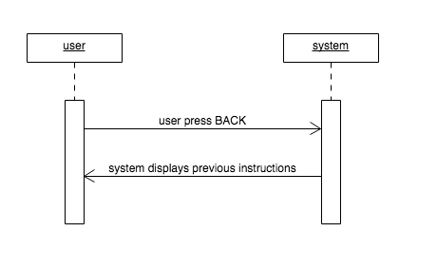

Figure Sequence diagram 3

# Implementation

### Research methods

Firstly, I have looked at a number of research papers to find the relevant documents. I was using online resources or journals, which provides the latest information and applications of Augmented Reality, from the Google Scholar engine and from Vuforia Development Portal. It searches for resources written by professional scientists, academic publishers, universities and other reliable websites.

### Creating an application

The first step to create the application was to get the assets for the MIRTO robot, which I have imported into my project. Once, the assets were imported, the most important part in this project was to find out, how to recognise all parts of MIRTO robot.

Firstly, I have used Image Target for all pieces. To get the right image, I took a pictures of the individual parts and tried to recognised them by the AR camera in the unity. To do so, I have imported the Images into Vuforia Database and imported them into my project.

For a testing purposes I have placed a simple UI object (cube) on the top of the Image target to see if it was tracked correctly. Because of the lighting and not very good captured pictures, the image targets were not recognised. For this reason, I have decided to edit them in the Adobe Photoshop. Once all the all images were edited, I have tried to track them again and this time it was successful. As you can see on the Figure17 below, the image displays feature and image rating, that the Vuforia uses to detect for the target image. The features are a sharp yellow crosses on the image. This feature captures the edges of the object. The rating defines how well can be image tracked and recognised using Vuforia SDK. The rating is for individual uploaded image and is rated from 0-5 stars. The higher the rating the target have, the better the tracking will be. If the Image have a zero rating, Vuforia indicate that the image is not tracked (Library.vuforia.com, 2019).

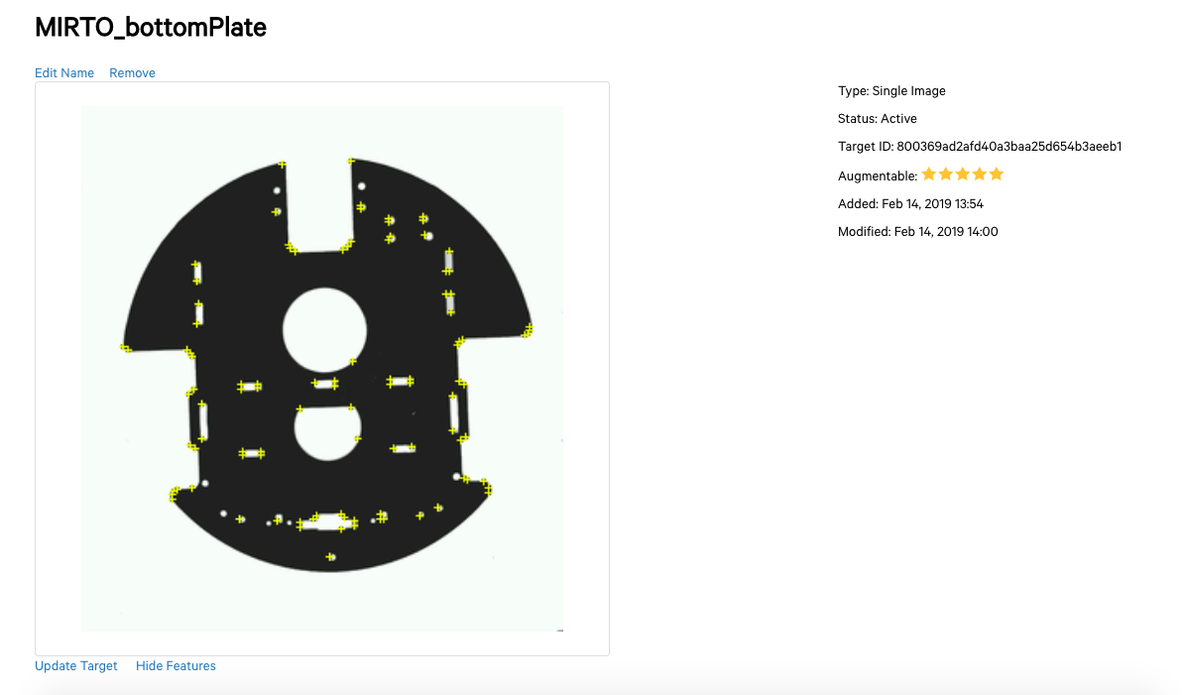

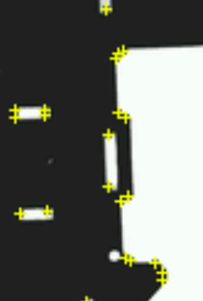

Figure Futures and rating of Image Target

Recognising all flat pieces which look the same from both sides, such as top and bottom plate, were recognised perfectly. However, it did not work on the object with different shapes. First, I have tried to use different side of the object as different Image target, but it did not work. Then I tried to use a cuboid target for a board part of the robot, which worked similar way as the image target. I have edited the images to fit the right measurements and also I adjusted the contrast of the target. Once the cuboid target was saved in the Vuforia database, it was imported into my project.

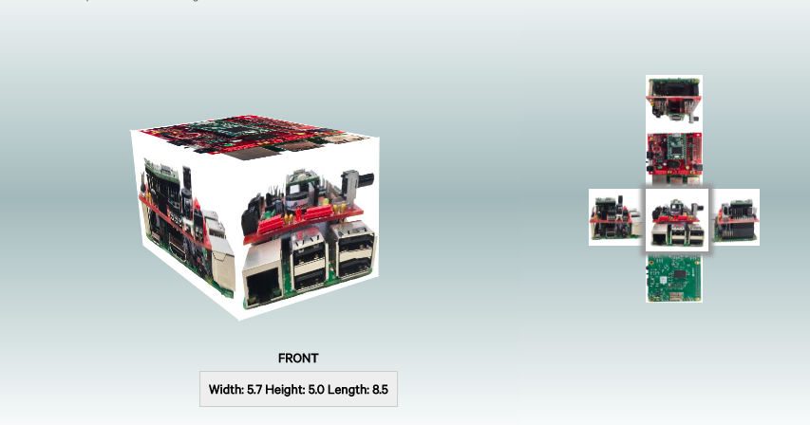

Figure Cuboid target

While testing the cuboid target in Unity, it was very difficult for the AR camera to recognise the object. I had to hold the board in the same straight position, as it was on the image, otherwise the recognition was lost very quickly. This was not an option, which could be used. For this reason, I moved on to object target.

Using an object target to get the 3D recognition of the part, must be created by using Vuforia Object Scanner. However, Vuforia Object Scanner is limited to Android devices only. It supports Samsung Galaxy S5 and higher and Nexus5. The application is not available to download from the app store. This application must be downloaded from Vuforia developer portal, downloads section under the Tools section from the link provided - <https://developer.vuforia.com/downloads/tool> . Once the application is installed, the user will be able to launch the application and the user will be able to use it as any other applications.

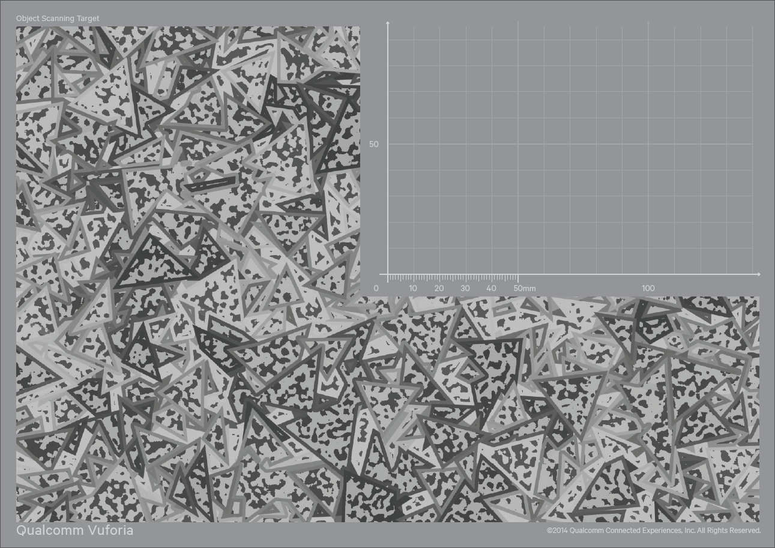

The scanner produces an Object Data file (.od) which is required to define in Vuforia Target Manager. Before scanning the object, I have download and print out the Object Scanning Target. Modifying the size of the target would affect the estimated physical object scale, so it is not recommended to do so. The Object Scanning Target is used to set up the position of the object to the local origin, which is represented as (0,0,0) in the left hand lowest corner of the grid. The scale of the Object Scanning Target grid is represented in millimetres.

Figure Object scanning target

On the Figure20 bellow, is shown as I was scanning the object using Object Scanning Target. When the object was scanned correctly from all sides it displays in green overlay. To scan the object correctly, both the object and the target cannot be moved during the recording.

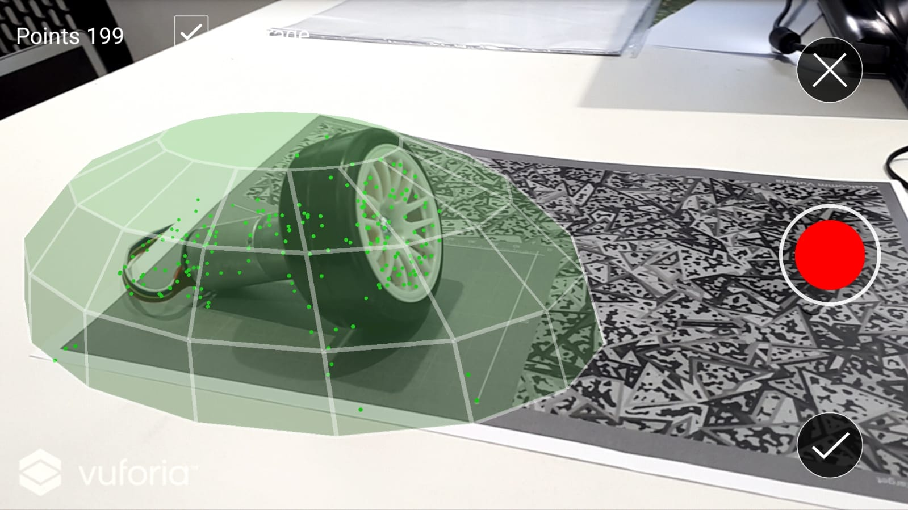

Figure Object scanning

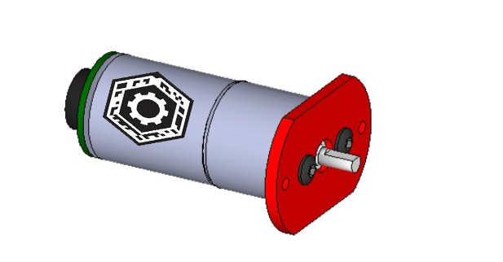Once the objects with different shapes and sizes were scanned from all sides. I have test this objects, if the they are correctly recognised inside the application. It was done by placing the object in front of the AR camera, the same way as image targets. I placed the simple UI object (cube) on the top, so if the object was correctly recognised it will show on the top of the target when the Unity is switched on the Play mode.

I had an issue of recognising the wheel target. In the scanner app the object works when tested, but inside the Unity it did not work well. For this reason, I had added an VU mark on the top of the object target as shown on Figure21. The scanner application will have more points to track. After trying this in Unity for the second time it worked perfectly.

Figure Motor- object target

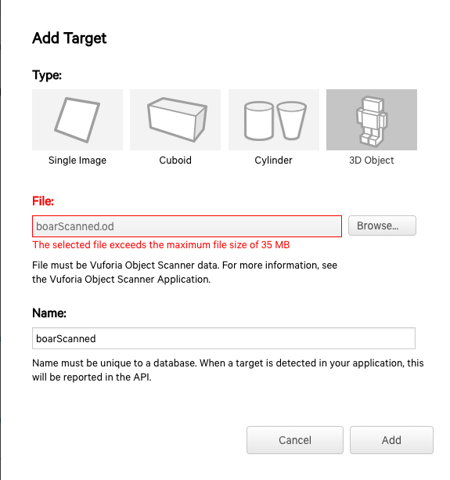

While adding the object target to Vuforia Database, I came across an issue, where Vuforia Scanner application produced way bigger file, then is actually allowed to upload. The scanned file was over 50MB where the Vuforia Database allows the user to upload only 35MB as shown on Figure22.

In my opinion, Vuforia Scanner application should not allow the user to scan over the limited size and warn the user of the limit before uploading the scanned 3D image to the database. For instance, on the top of the target instead of showing how many points have been tracked, which is not really useful for user, could be replace with the size of the scanned image.

Figure uploading .od file

Once all the main parts were tracked and able to recognised by the AR camera in Unity, the next step was to work on the design of the application. Firstly, the software will be designed as shown on the Figure23 and Figure24 below. Once the image target will be detected, the Mirto will animate 6 main parts of the robot: board, top plate, skeleton, bottom plate, wheels and roller. For instance, if the user picks up the frame side plate to the AR camera view on playing mode, it will show the animation with the main parts. The main part will move down from the Mirto skeleton and move back, where the part belongs.

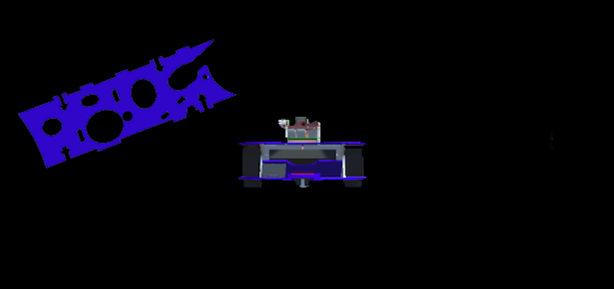

Figure

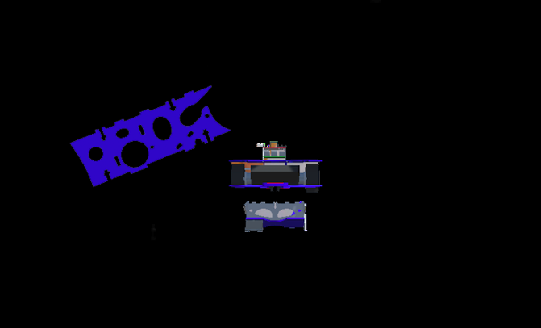

Figure

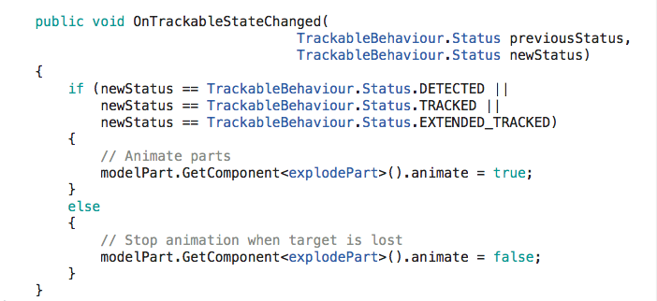The animation will start playing, when the image target will be detected at run time. The animation was created using a trackable behaviour status, which will update the model par to true or a false, as shown on the Figure25.

Figure Animating part - code

The script (animatePart) was attached to individual Image Target. Each Image Target have its own model part, as shown on the Figure26 bellow.

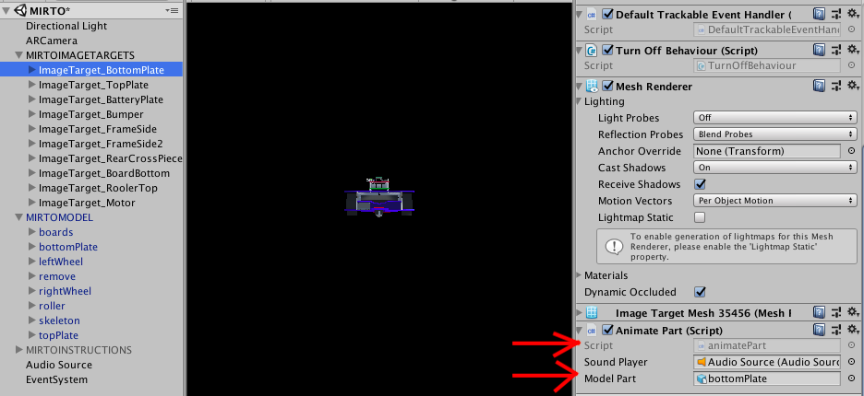

Figure

Model of the robot have attached script (explodePart). This script has assigned initial position, a speed that the part will be exploding and the distance how far the part will animate. For instance, if the user will show the bottom plate of the Mirto robot to the AR camera, the bottom plate on the main robot in the middle of the screen will explode to the assigned direction down. It will go down as it is the Explode Direction String is set to down as shown on the Figure28.

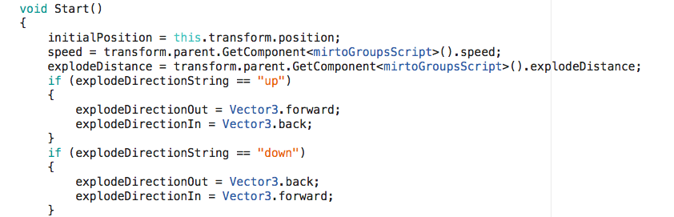

Figure

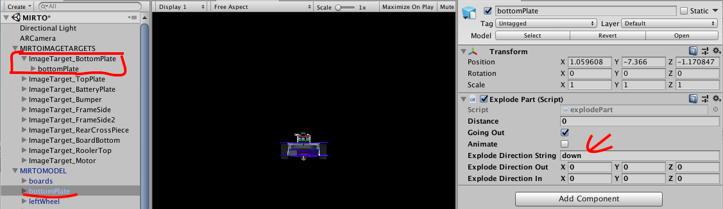

Figure

Once the animation was set up for each target, the audio feedback was attached to the script as well. The Audio Source was downloaded from the Asset store and imported into my project. In the animatePart script, a Sound Player was crated. Inside the inspector of the image target, I dragged and dropped the audio as shown on the Figure29. Once the image target was detected, both the animation and the sound will be played. The audio is played just once, when detected the image or object target.

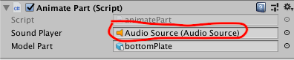

Figure

The following step, was to show the 3D part on the top of the image target, when the AR camera correctly recognising the image or object target. The 3D part will also have the attached parts, which needs to be assembled together. Once the AR camera recognise the image target, it will overlay the target with an actual 3D part.  Individual part will have its own overlay.

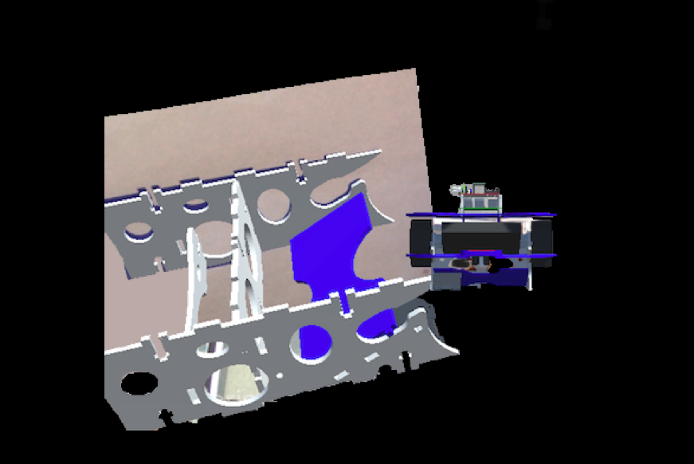

Frame side part of the robot will show all attached components as shown on the Figure25. However, if the user picks up one of the components that is part of the skeleton already it will only show one more attached part as shown on Figure31.

Figure

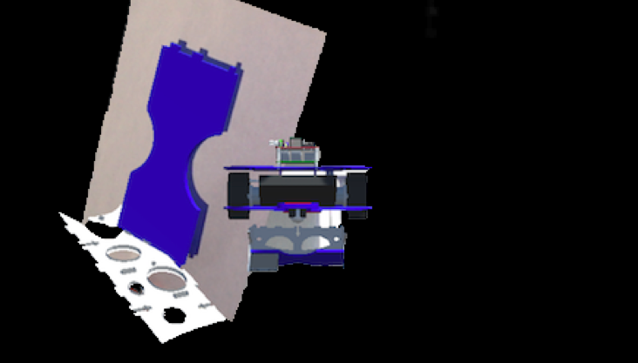

Figure Two Attached 3D parts

The next step was to provide a user with an instruction, which will help them to assemble the Mirto robot. As can be seen on Figure32 bellow. The user will be able to assemble the Mirto parts together by picking up the listed hardware and showing them into the AR camera for viewing how they are attached together. The main hardware will be highlighted in the list, so the user will know, that they will be able to look at that part with the AR camera which overlays with a specific hardware and animation. After the user completes first step assembling parts together, user needs to press the NEXT button. The button is located at the right side of the screen under the instructions and it will display new instructions, that the user needs to follow. The user can also go back to the previous instructions, by clicking on the BACK button. The button will be located at the bottom left side of the screen.

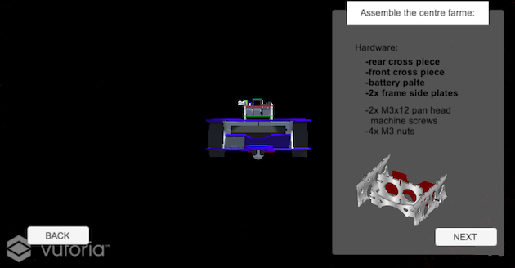

Figure Assembling instructions

## Implementing prototype into Hololens

When implementing prototype into Hololens headset, the application must run on low cost to achieve the required results. However, the complexity of the 3D model comprises the workload are computationally expensive. The problem for the Hololens is that the geometric model was built to help manufacturing the Mirto not for drawing at interactive speeds and it had about 750 000 vertices and is too complex to the top display at the required frame rate what was about 60 frames per second. At the moment it can run as slow as 12 fps. We have tried to reduce the complexity of the model but have not made sufficient progress. For this reason, the prototype on Hololens headset will use only image targets.

# Testing and Results

For Augmented Reality software testing it is very important to set up correct environments. To test the application, all physical parts of the robot in various angles and sizes were tested under different lighting. Firstly, the test was done in Unity environment, in the Play mode and later on, the project was tested on Hololens headset.

## Testing the app in Unity

The testing was done during the development after each feature has been implemented.

### Testing the Image Targets

The image targets for the flat pieces of the robot were tested first. For a testing purposes I have placed a simple UI object (cube) on the top of the Image target to see if it was tracked correctly. Because of the lighting and not very good captured pictures, the image targets were not recognised. For this reason, I have decided to edit them in the Adobe Photoshop. Once all the images were edited, I have tried to track them again and this time it was successful.

### Testing the Object Targets

To test the objects with different shapes and sizes, I have placed the object in front of the AR camera, the same way as image targets. I placed the simple UI object (cube) on the top, so if the object was correctly recognised, it will show on the top of the target when the Unity is switched on the Play mode.



Figure object target - motor

I had an issue of recognising the wheel target. In the scanner app the object works when tested, but inside the Unity it did not work well. For this reason, I had added a VU mark on the top of the object target as shown on Figure28. The scanner application will have more points to track. After trying this in Unity for the second time, it worked perfectly.

### Testing the animation and the sound

Each part of the robot has its own animation. To test, if the parts are animating correctly, the object was placed in the front of the AR camera and see if the part on the main Mirto animated and played the audio.

### Testing the buttons

The only inputs that user uses are two buttons ‘NEXT’ and ‘BACK’. The system consists of eleven different instructions. To test if the Next and Back buttons work correctly, I have compared them if they are in the order as it was created inside the Unity. The Next button will navigate the user to the last instructions, where the challenging part is assigned. In the last instructions, there is no NEXT button implemented, as there are no more instructions left. Similar to the BACK button, in the first instructions this button is not displayed as there are no instructions before.

## Testing the app on Microsoft Hololens headset

When testing the prototype on the Hololens headset, the battery consumption is very high, therefore, the battery need to be charged before use.

### Testing Voice recognition

After the user completes first instructions, assembling parts together, user says Next. Once the headset recognising the word Next, the system will display new instructions. The user can always come back to previous instructions of tutorial by saying Back. Once the headset recognising the word Back, the system will display previous instructions.

# Evaluation and Further Work

## Methods

### Questionnaire types

The questionnaire consists of the open and the close type of questions. The closed type of question focuses on collecting quantitative data, where the respondent can choose from selections of possible answers. The open ended type of question fosses on qualitative measurements. It does not provide pre-set answer options, but it enables to collect varied opinions.

### Justification for my questionnaire

To collect various data, different types of questions were used. For instance, the second question used Likert scales. Likert scales are closed type of question, where the respondent can select from scale 1-9, how easy was to follow the instructions (Llauradó, 2018). To collect more accurate answers, even number of options were used, to prevent an irrational response, which will provide either positive or a negative answer.

### Ensuring privacy and anonymity

Before handling a questionnaire, each student was fully informed about privacy and anonymity due to a Data Protection Act (GOV.UK, 2018). Once the data will be collected, all the information will be in locked in safe place and will not be shared with anyone. If the date will be collected electronically, the data will be secured with password due to Computer Misuse Act (Legislation.gov.uk, 2019).

## Results

The sample group consist of 10 participants. The feedback was collected from the first year Computer Science undergraduate students at Middlesex University on 16 to 17 April 2019 between 9:00 – 17:00. The questionnaire was printed in the form and students were taking a moment to complete them after trying the application on both the desktop device and the Hololens headset.

### Data-analysis

The results were collected in Excel and then single bar graphs; double bar graph or pie charts were created. The created charts, were used for understanding the data in a visual form. On the quantitative data, additional chart elements were used for better understanding.

### Aim of the results

The most important part of the evaluation is to find, how and to what extend Augmented Reality based system can be benefit the use of tutorial approach for students. In order to test the effectiveness of the AR system approach, a traditional paper handout was printed out for comparison. The project was tested by allowing students to use the application and I have collected a feedback regards to the usage of AR versus the use of paper handouts.

### Result 1

Question1 (Can you imagine this application being used in education?)

The purpose of this closed question was to analyse the findings of how much the students would like to use this application as part of their studies. The participants could choose from the answers ‘Yes’ or ‘No’. Please see the bar graph below, with information about what students think.

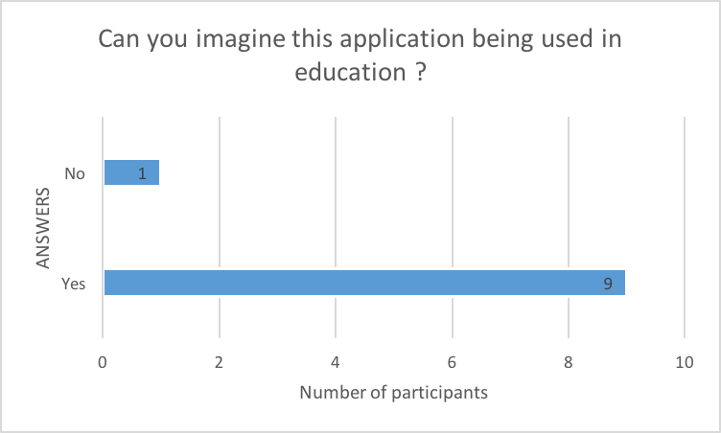

Figure

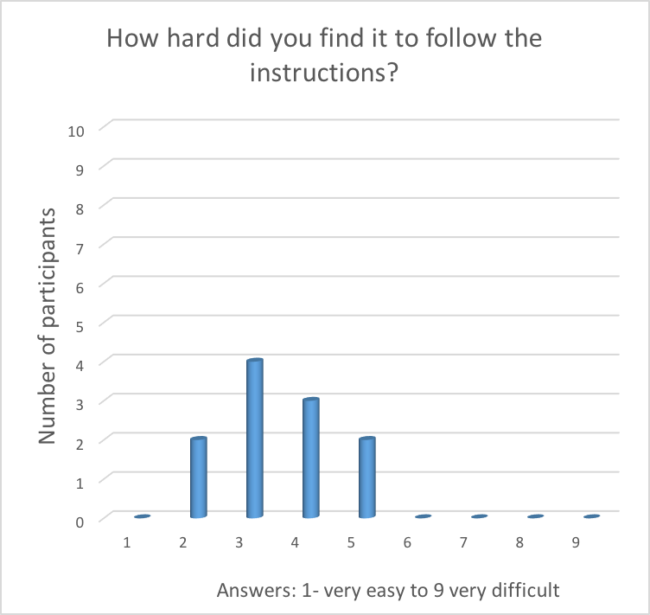The bar graph compares the answers, where individual student said ‘Yes’ if they do think that this application should be used in education or ‘No’ if they do not agree or think it should be used. It can be clearly seen that the highest rate of answers was positive, where 9 out of 10 said ‘Yes’. The students strongly agree about using this application as part of their study. However, one participant disagrees.

### Result 2

Question2(How hard did you find it to follow the instructions?)

The students were asked this question in purpose for future developing improvements. They could choose how hard was to understand the instructions on scale from 1-9, where the 1 is very easy and 9 very hard.

The instructions were not very hard to understand, but also it was not very easy as well. The participants will need to be provided with more detailed instructions.

Figure

As can be seen on the Figure35, most chosen answer from the nine possible answers, was a tree- (4 participants) and four- (3 participants), which is still considered that it was easy, but could be improved a bit more. The following answers were, number two and five, where the 2 participants of each number picked up this answer. No one of these participants answered number one, that the instructions were very easy to follow, but most positively no one picked up the number six, seven, eight or nine, which would indicate that the instructions were very hard to follow.

### Result 3 and Result 4

Question3(How hard did you find it to navigate to the new or previous instructions when trying on the desktop?)

Question4(How hard did you find it to navigate to the new or previous instructions when trying on the Hololens?)

The double bar graph below compares answer from two questions on how hard was to navigate to the new or previous instructions, when trying on the desktop vs Hololens. The participants could choose from the scale, from 1-9, where the 1 is very easy and 9 very hard. Please see the graph below, for more details.

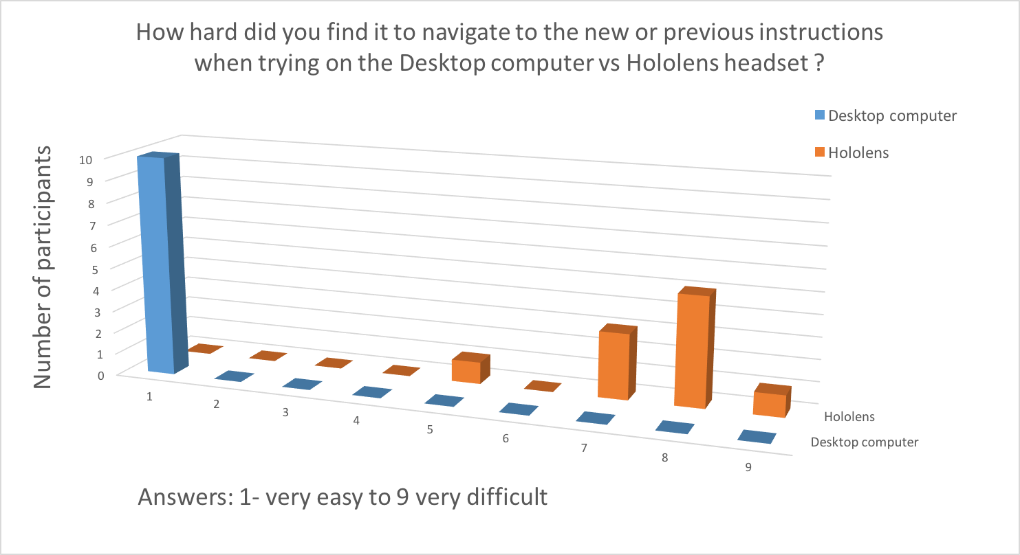

Figure

It can be clearly seen that 100% of participants answered that the navigation of the new or previous instructions on the desktop was very easy. When prototyping on desktop computer, users had to use mouse click, which was very easy to do. However, when using the Hololens headset, user finds it very difficult to move to the following instruction. The Hololens headset uses voice-based interactive system. The user needs to say next to move to the new instructions or go back to go to the previous one. Most of the time users had to repeat themselves for the system to recognise their command.

### Result 5

Question5(Has using this application increased your motivation to assemble the robot?)

Another question for students was, if they think that using AR increases their motivation to learn how to assemble a Mirto robot together, compared to the traditional way. The students could choose from the scale, from 1-9, where the 1 is very easy and 9 very hard. Please see the single line graph on the Figure37, for more information.

Figure

Most students were amazed with the technology and I had mostly positive feedback. Students were more passionate for the task when using the “virtual world” show them the instructions. According to the graph, more than 50% choose number 1, that following the instructions using new technology is way more interesting comparing to paper handouts. Two students pick up number 2 and one students number 3, which is still very positive. However, one participant answered number 7, that it did not increase the motivation for assembling the robot together.

### Result 6

Question6(Do you think this application offers advantages in contrast to the traditional textbook?)

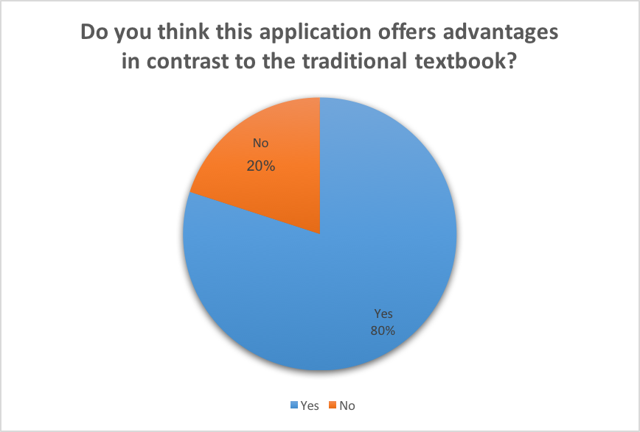The purpose of this question was to find how and to what extend using this Augmented Reality based system can be benefit the use of tutorial approach for students. The participants could choose from the answers ‘Yes’ or ‘No’. Please see the pie chart on the Figure38, with information about what students think.

Figure

The chart shows that 80%, asked participants thinks, that it does take the advantage over the traditional textbooks. However, another 20% disagreed.

# Conclusion

Augmented Reality has rapidly become one of the most exciting technology, which shows a big interest in education and professional trainings. The goal of this project was to create a teaching tool to help students assemble MIRTO robot. To demonstrate this teaching tool, AR application was created. Students are able to follow the manual instruction which helps them to assemble Mirto robot step by step. Instructions highlights the part of the robot which can be explored inside the AR camera and illustrate which parts belongs together. The system also shows the animation where the particular main part will belong in the whole robot. The robot is divided into 6 main parts: board, top plate, skeleton, bottom plate, wheels and roller. The application was built for Hololens headset, but can also be used for Google cardboard headset, which is more affordable for university, to equip for this usage.

The project was evaluated by allowing students to use the application and I have collected a feedback regards to the usage of AR in education. According to my results, it concludes that using AR can be a useful teaching tool, as it increases not only the motivation of a student, but also inability to focus way more, than just reading the simple paper handouts.

It would be interesting to conduct this experiment with additional improvements. For instance, students had an issue using the voices-based interactive system, in the future, clickable virtual buttons will be implemented instead of voice recognition. When the pointer is placed directly on the top of the targeted button, the user will be able to press with an air-tab gesture.

This study might be included as part of the SOB for first year undergraduate students. Furthermore, it will be a great opportunity for universities to bring the classes to different level of studies and build strong interest for students. However, there are several limitations in this application. I had a small set of participants, therefore, it would be necessary to repeat the study with more students. Furthermore, some of the participants have had a limited assembling experience, which might have affected the results as well.

There exist many future research directions which could be explored. For instance, the assembling application can be extended with more interactive way or integrating a virtual tutor, tutoring how to assemble the robot. The researches have shown that using virtual characters into tutoring environment can be beneficial by increasing student’s motivation (Johnson, 2007).

# Bibliography

|  |
| --- |
| Augment News. (2018). *5 reasons to use Augmented Reality in Education - Augment News*. [online] Available at: https://www.augment.com/blog/5-reasons-use-augmented-reality-education/ [Accessed 18 Oct. 2018]. |
| Bentley Communities. (2018). *Using the HoloLens to facilitate plant maintenance*. [online] Available at: https://communities.bentley.com/other/old_site_member_blogs/bentley_employees/b/stephanecotes_blog/posts/using-the-hololens-to-facilitate-plant-maintenance [Accessed 3 Nov. 2018].  Blum, A. (2018). *The Face of Entertainment is Changing Because of Augmented Reality*. [online] VRFocus. Available at: https://www.vrfocus.com/2018/10/the-face-of-entertainment-is-changing-because-of-augmented-reality/ [Accessed 18 Jan. 2019]. |
| Developer.apple.com. (2019). *ARKit - Apple Developer*. [online] Available at: https://developer.apple.com/arkit/ [Accessed 13 Jan. 2019]. |
| Goodwin, A. (2018). *Car Tech - Hyundai's Augmented Reality app overhauls the owners manual*. [online] YouTube. Available at: https://www.youtube.com/watch?v=MDtxOmtVZGs [Accessed 30 Dec. 2018].  GOV.UK. (2018). *Data protection*. [online] Available at: https://www.gov.uk/data-protection [Accessed 10 Apr. 2019]. |
| iSpot.tv. (2019). *LEGO Nexo Knights TV Commercial, 'New Way to Play'*. [online] Available at: https://www.ispot.tv/ad/ARE8/lego-nexo-knights-new-way-to-play [Accessed 2 Jan. 2019]. |
| Iyer, G. (2017). *What is the best Augmented Reality Toolkit available?*. [online] Hedgehoglab.com. Available at: https://www.hedgehoglab.com/blog/best-augmented-reality-toolkits [Accessed 13 Jan. 2019].  Johnson, W. (2007). *Proceedings of the Artificial Intelligence in Education*. [online] ResearchGate. Available at: https://www.researchgate.net/publication/221297390_Serious_Use_of_a_Serious_Game_for_Language_Learning [Accessed 22 Apr. 2019]. |
| Kar, I. (2016). *Snapchat has quietly introduced the world to augmented reality*. [online] Quartz. Available at: https://qz.com/715103/snapchat-has-quietly-introduced-the-world-to-augmented-reality/ [Accessed 31 Dec. 2018]. |
| Kazovskaya, D. (2016). *Five Top Augmented Reality Tools for Creating AR Applications - Azoft*. [online] Azoft. Available at: https://www.azoft.com/blog/ar-applications/ [Accessed 13 Jan. 2019]. |
| Kevin, M. (2018). *How Microsoft Hololens is being used in Education*. [online] VRedtech.com | Virtual Reality Education Technology. Available at: https://vredtech.com/blogs/news/how-microsoft-hololens-is-being-used-in-education [Accessed 18 Oct. 2018].  Legislation.gov.uk. (2019). *Computer Misuse Act 1990*. [online] Available at: https://www.legislation.gov.uk/ukpga/1990/18/contents [Accessed 10 Apr. 2019]. |
| Library.vuforia.com. (2018). *VuMark*. [online] Available at: https://library.vuforia.com/articles/Training/VuMark [Accessed 2 Jan. 2019]. |
| Library.vuforia.com. (2019). *Cylinder Targets*. [online] Available at: https://library.vuforia.com/content/vuforia-library/en/articles/Solution/Cylinder-Targets-Guide.html [Accessed 2 Jan. 2019]. |
| Library.vuforia.com. (2019). *Image Targets*. [online] Available at: https://library.vuforia.com/articles/Training/Image-Target-Guide [Accessed 2 Jan. 2019]. |
| Library.vuforia.com. (2019). *Model Targets User Guide*. [online] Available at: https://library.vuforia.com/content/vuforia-library/en/articles/Solution/model-targets-user-guide.html#def [Accessed 3 Jan. 2019]. |
| Library.vuforia.com. (2019). *Multi-Targets*. [online] Available at: https://library.vuforia.com/articles/Training/Multi-Target-Guide.html [Accessed 3 Jan. 2019]. |
| Library.vuforia.com. (2019). *Object Recognition*. [online] Available at: https://library.vuforia.com/articles/Training/Object-Recognition [Accessed 2 Jan. 2019]. |
| Library.vuforia.com. (2019). *VuMark Design Guide*. [online] Available at: https://library.vuforia.com/articles/Training/VuMark-Design-Guide [Accessed 2 Jan. 2019].  Library.vuforia.com. (2019). *Optimizing Target Detection and Tracking Stability*. [online] Available at: https://library.vuforia.com/articles/Solution/Optimizing-Target-Detection-and-Tracking-Stability.html [Accessed 21 Mar. 2019].  Llauradó, O. (2018). *Likert scale: what it is and how to use it*. [online] Netquest.com. Available at: https://www.netquest.com/blog/en/likert-scale [Accessed 5 Nov. 2018]. |
| ManageEngine ADSolutions (2019). *What is the best augmented reality software? - Quora*. [online] Quora.com. Available at: https://www.quora.com/What-is-the-best-augmented-reality-software [Accessed 13 Jan. 2019]. |
| Mayoral, J. (2018). *Augmented Reality - 5 facts you should know | Augmented Reality SDK*. [online] Augmented Reality SDK. Available at: https://www.viewar.com/5facts-on-augmented-reality/ [Accessed 30 Dec. 2018]. |
| McCarthy, J. (2017). *Did Pokemon Go really change how marketers view augmented reality?*. [online] The Drum. Available at: https://www.thedrum.com/news/2017/07/07/did-pokemon-go-really-change-how-marketers-view-augmented-reality [Accessed 31 Dec. 2018]. |
| Medium. (2018). *Every (Major) AR Development Platform and Why It’s Important*. [online] Available at: https://medium.com/inborn-experience/every-major-ar-development-platform-and-why-its-important-fbd9bc300fd5 [Accessed 13 Jan. 2019].  Morpus, N. (2018). *5 Experiential Learning Augmented Reality Apps for Education*. [online] Blog.capterra.com. Available at: https://blog.capterra.com/experiential-learning-augmented-reality-apps-for-education/ [Accessed 18 Jan. 2019]. |
| Ong, T. (2018). *This conceptual AR app helps you build Ikea furniture*. [online] The Verge. Available at: https://www.theverge.com/tldr/2018/3/22/17151440/conceptual-ar-app-ikea-furniture [Accessed 4 Dec. 2018]. |
| Pagani, A., Henriques, J. and Stricker, D. (2016). [online] Int-arch-photogramm-remote-sens-spatial-inf-sci.net. Available at: https://www.int-arch-photogramm-remote-sens-spatial-inf-sci.net/XLI-B1/1173/2016/isprs-archives-XLI-B1-1173-2016.pdf [Accessed 14 Jan. 2019]. |
| Radke, F. (2018). *How Augmented Reality Will Change Education Completely.* [online] YouTube. Available at: https://www.youtube.com/watch?v=5AjxGqzqQ54 [Accessed 3 Nov. 2018]. |
| Ranosa, T. (2018). *Doctors Can Now Practice Surgical Procedures Through Augmented Reality*. [online] Tech Times. Available at: https://www.techtimes.com/articles/191608/20170107/doctors-can-now-practice-surgical-procedures-through-augmented-reality-heres-a-closer-look-at-touch-surgery.htm [Accessed 31 Dec. 2018]. |
| Rouse, M. (2015). *What is Microsoft HoloLens? - Definition from WhatIs.com*. [online] SearchMobileComputing. Available at: https://searchmobilecomputing.techtarget.com/definition/Microsoft-HoloLens [Accessed 17 Jan. 2019]. |
| Tank, V. (2017). *What is unity game engine?*. [online] Quora. Available at: https://www.quora.com/What-is-unity-game-engine [Accessed 17 Jan. 2019]. |
| Technologies, U. (2019). *Store - Unity Store*. [online] Unity Store. Available at: https://store.unity.com/ [Accessed 17 Jan. 2019]. |
| Vr.google.com. (2019). *Get Cardboard – Google VR*. [online] Available at: https://vr.google.com/intl/en_uk/cardboard/get-cardboard/ [Accessed 16 Jan. 2019].  Webel, S., Bockholt, U., Engelke, T. and Peveri, M. (2011). [online] Elib.dlr.de. Available at: https://elib.dlr.de/73414/1/bioconf_skills_00097%5B1%5D.pdf [Accessed 18 Jan. 2019]. |
|  |